Install ROS nmea_navsat_driver enhanced driver

- Log into the Tractor
- $ cd catkin_ws/src
- $ git clone https://github.com/ros-agriculture/nmea_navsat_driver.git
- $ cd ..
- From ~/catkin_ws, $ catkin_make
- $ source devel/setup.bash
- $ rospack find nmea_navsat_driver # returns /home/al/catkin_ws/src/nmea_navsat_driver
- Launch sublime and open nmea_serial_driver.launch
- 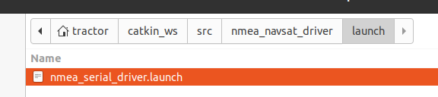

- $ cd /home/tractor/catkin_ws/src/nmea_navsat_driver/launch
- Update the gps port and baud input info
  - Open FileZilla
  - Go to /home/ubuntu/catkin_ws/src/nmea_navsat_driver/launch
  - Edit nmea_serial_driver.launch - a udev rule for “gps” needs to be in place
From | To
<arg name="port" default="/dev/ttyUSB0" />  <arg name="baud" default="4800" /> | <arg name="port" default="/dev/gps" />  <arg name="baud" default="115200" />

- $ roslaunch nmea_serial_driver.launch

Trying the non-ROSAG version
- Log into the Tractor
- $ cd catkin_ws/src
- Delete the previous version
- Trying, $ git clone https://github.com/ros-drivers/nmea_navsat_driver.git
- $ cd ..
- From ~/catkin_ws, $ catkin_make

Failed
-- Could NOT find catkin_virtualenv (missing: catkin_virtualenv_DIR)

$ sudo apt-get install ros-noetic-catkin-virtualenv
#### Running command: "make -j2 -l2" in "/home/tractor/catkin_ws/build"
####
Scanning dependencies of target nmea_navsat_driver_generate_virtualenv
[ 25%] Generate virtualenv in /home/tractor/catkin_ws/build/venv
True
[ 50%] Install requirements to /home/tractor/catkin_ws/build/venv
ERROR: launchpadlib 1.10.13 requires testresources, which is not installed.
[ 75%] Prepare relocated virtualenvs for develspace and installspace
[100%] Per-package virtualenv target
[100%] Built target nmea_navsat_driver_generate_virtualenv
tractor@tractor-HP-ProBook-645-G1:~/catkin_ws$

sudo apt install python3-pip

- $ source devel/setup.bash
- $ rospack find nmea_navsat_driver # returns /home/al/catkin_ws/src/nmea_navsat_driver
- Launch sublime and open nmea_serial_driver.launch
- Make sure power is turned on to the GPS board and there are lights associated with receiving satellite signals

If you need to add a debug statement to print the nmea sentences
Folder: /home/ubuntu/catkin_ws/src/nmea_navsat_driver/src/libnmea_navsat_driver
Program: driver.py

rospy.loginfo("nmea_string: %s", nmea_string) # added line 173 for debugging

- $ roslaunch nmea_serial_driver.launch

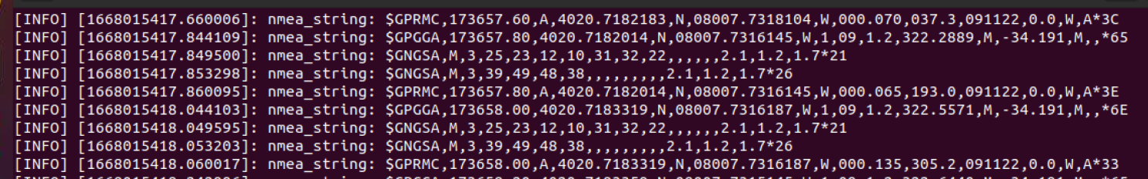

Comparing ROSAg and ROS

ROS Ag  https://github.com/ros-agriculture/nmea_navsat_driver/blob/master/src/libnmea_navsat_driver/driver.py | ROS  https://github.com/ros-drivers/nmea_navsat_driver/blob/master/src/libnmea_navsat_driver/driver.py
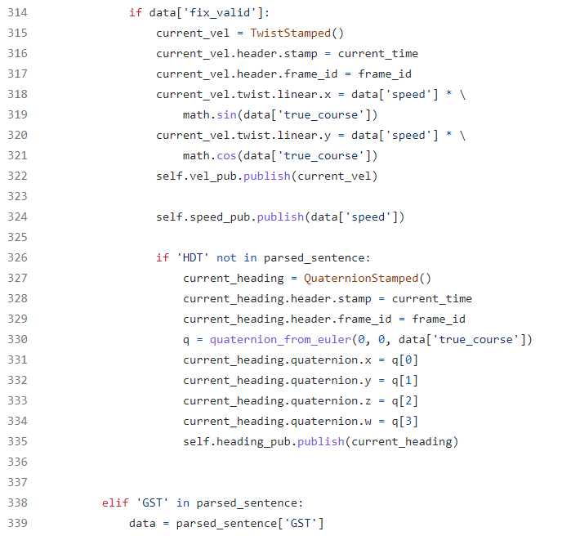 | nmea_navsat_driver/driver.py at master · ros-drivers/nmea_navsat_driver · GitHub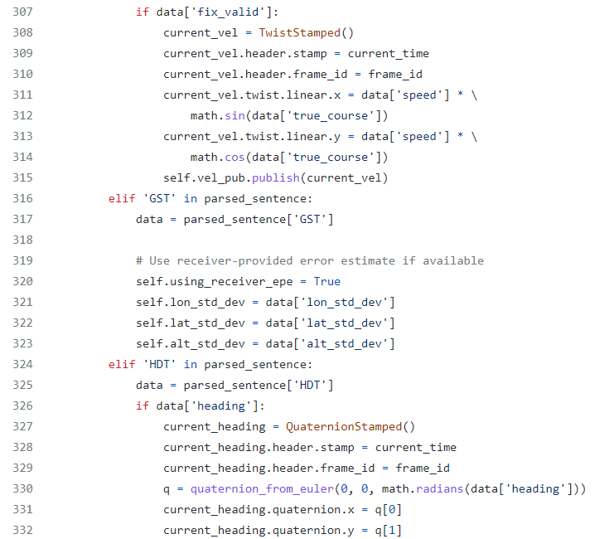
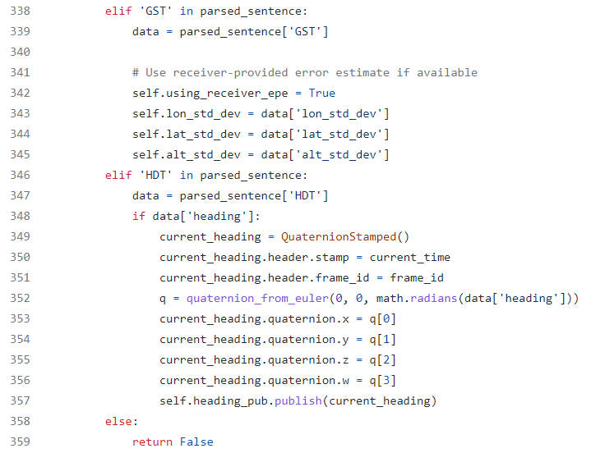 | 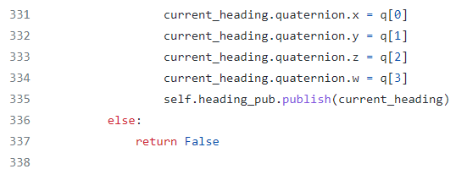
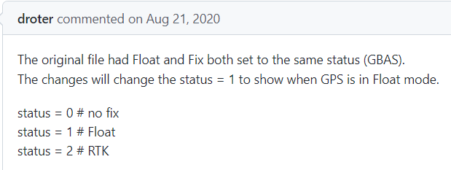
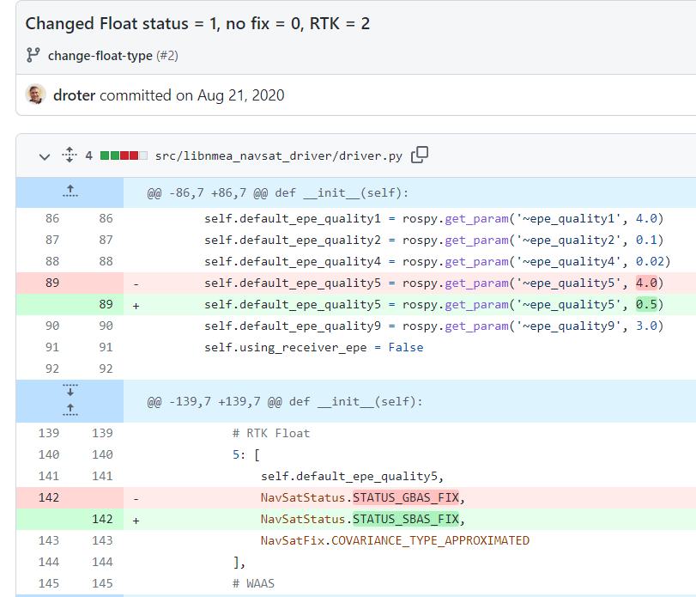
This is not committed
Note: https://docs.ros.org/en/jade/api/sensor_msgs/html/msg/NavSatStatus.html
int8 STATUS_SBAS_FIX = 1 # with satellite-based augmentation
int8 STATUS_GBAS_FIX = 2 # with ground-based augmentation

GPS Quality indicator:
0: Fix not valid
1: GPS fix
2: Differential GPS fix, OmniSTAR VBS
4: Real-Time Kinematic, fixed integers
5: Real-Time Kinematic, float integers, OmniSTAR XP/HP or Location RTK

This was in my startup procedures:
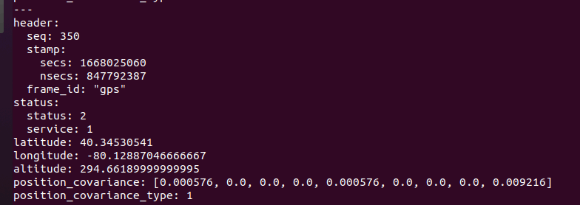
It suggests to me a “status” of 2 equates to a “good” RTK fix

You could try and use plotjuggler to plot the LAT/LON and see the drift

OLD NOTES FOR REFERENCE ONLY
Reference: https://github.com/ros-agriculture/nmea_navsat_driver

The base driver has been enhanced to publish speed and heading.

On Rpi:
- PuTTy into RPi $ plink RPI_on_ZeroTier -pw ubuntu
- $ cd catkin_ws/src
- $ git clone https://github.com/ros-agriculture/nmea_navsat_driver.git
- cd ..
- From ~/catkin_ws, $ catkin_make
- $ source devel/setup.bash
- $ rospack find nmea_navsat_driver # returns /home/al/catkin_ws/src/nmea_navsat_driver
- $ cd /home/ubuntu/catkin_ws/src/nmea_navsat_driver/launch
- Update the gps port and baud input info
  - Open FileZilla
  - Go to /home/ubuntu/catkin_ws/src/nmea_navsat_driver/launch
  - Edit nmea_serial_driver.launch
From | To
<arg name="port" default="/dev/ttyUSB0" />  <arg name="baud" default="4800" /> | <arg name="port" default="/dev/gps" />  <arg name="baud" default="115200" />

- $ roslaunch nmea_serial_driver.launch

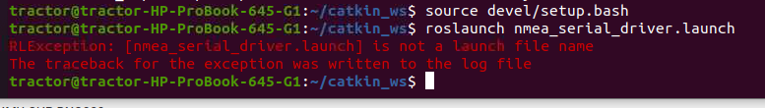
If you need to add a debug statement to print the nmea sentences
Folder: /home/ubuntu/catkin_ws/src/nmea_navsat_driver/src/libnmea_navsat_driver
Program: driver.py

rospy.loginfo("nmea_string: %s", nmea_string) # added line 163 for debugging

Check the GPGGA sentence after the longitude to see what the status is. The example below is “0”; I had to start the RTK base station and move the tractor outdoors.
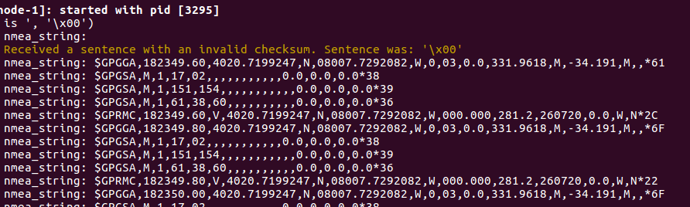

Afterwhich I am getting a 4 for status with 9 satellites.
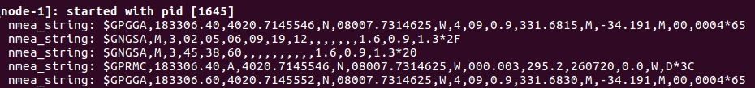

$ rostopic echo /fix
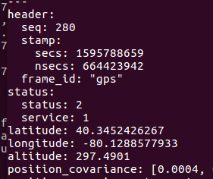

Power up the base station sending correction data
Power up the tractor gps
$ roslaunch /home/tractor/catkin_ws/src/nmea_navsat_driver/launch/nmea_serial_driver.launch

11/19/22
Gps-odom uses “import geonav_transform.geonav_conversions as gc”

https://get-help.robotigniteacademy.com/t/no-module-name-geonav-transform-geonav-conversions/14494/5

$ cd /home/tractor/catkin_ws/src
$ git clone https://github.com/bsb808/geonav_transform.git
$ cd /home/tractor/catkin_ws/
$ catkin_make
$ source devel/setup.bash; rospack profile
Above did not produce errors, but gps_odom.py could not find library

$ python gazebo_elestero_ex.py

python3 -m pip install "SomeProject"
python3 -m pip install "geonav_transform"

